Construction Specialties

Representative Electronic Order Write-Up Sheet

Two steps are required to complete the Representative Electronic Order Write-up Sheet:

Step 1: Search for the open quote, mark it closed and change it from a quote to an order.
Step 2: Fill out the Representative Electronic Write-up Sheet on screen and print it.

Follow the scripts below to complete the two steps noted above.

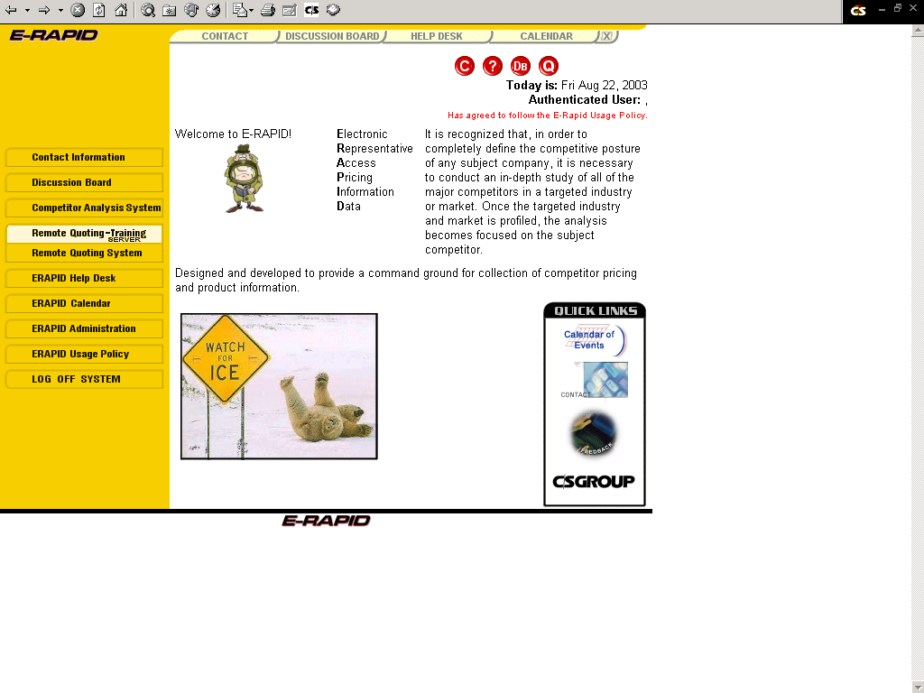
Use the “Production” or “Training” server to access the new “Representative Order Write-up Sheet”. Please create all practice quotes in the training server as these will not affect your live or production quotes.

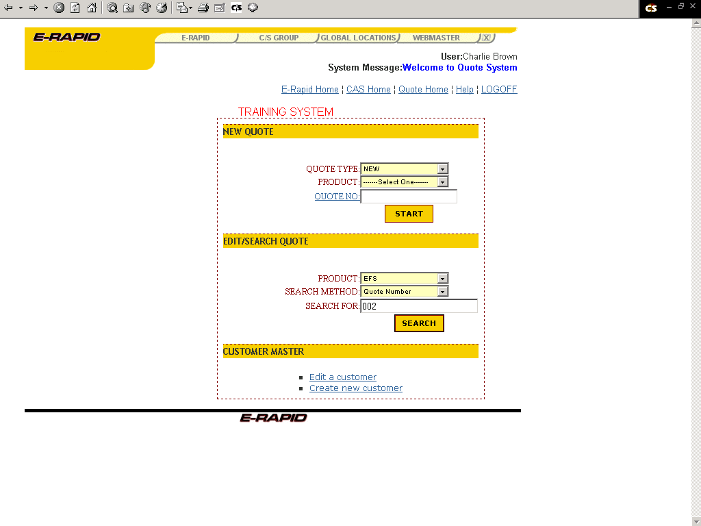

Search for the original quote in the standard way, using the Architect Name, Bid Date, Customer Name, Quote Number or Project Name.

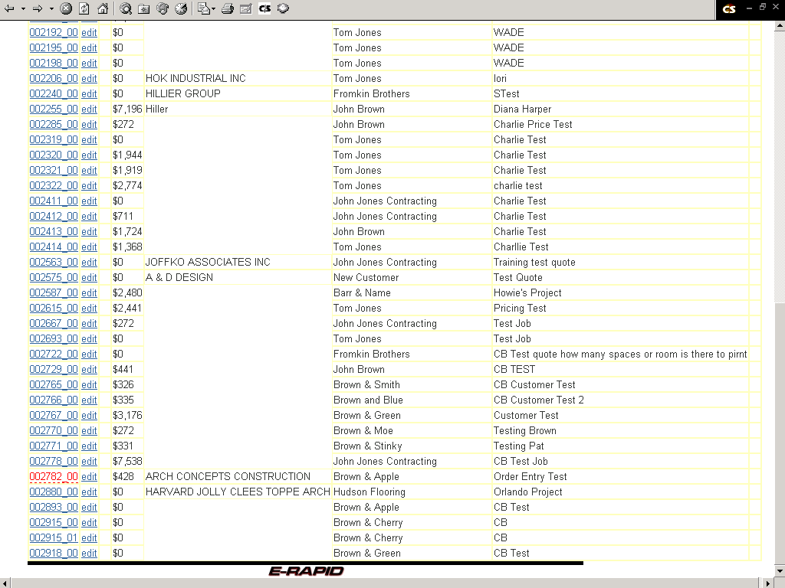

Click on the quote number of the quote to be changed to an order.

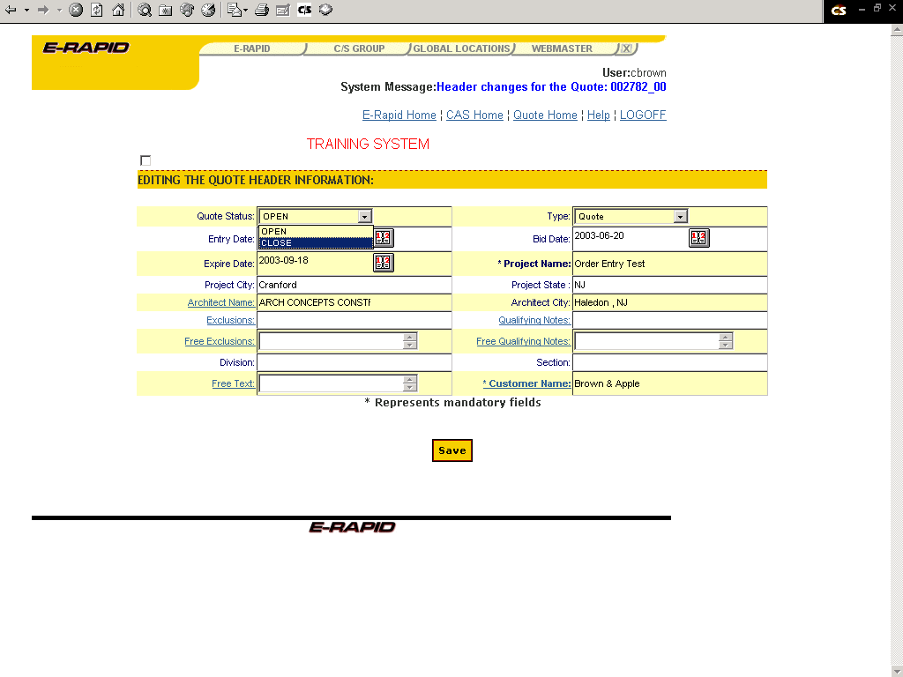

In the “Quote Status” field, click on “Close.”

In the “Type” field, click on “Order.”

Click on the yellow “Save” button at the bottom of the screen.

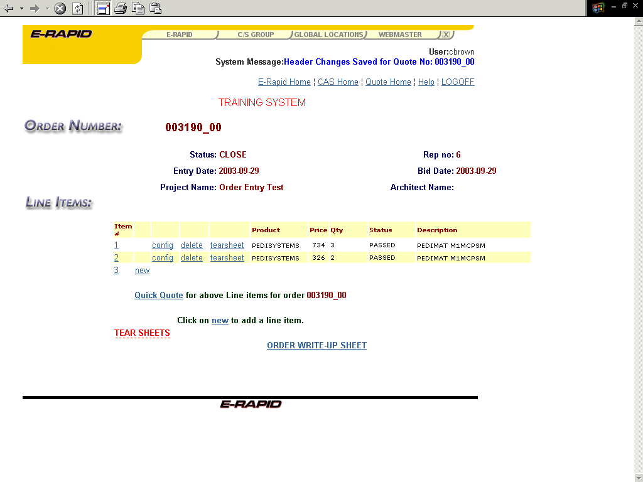

At the bottom of the screen, click on the words: “ORDER WRITE-UP SHEET” to access the order write-up sheet.

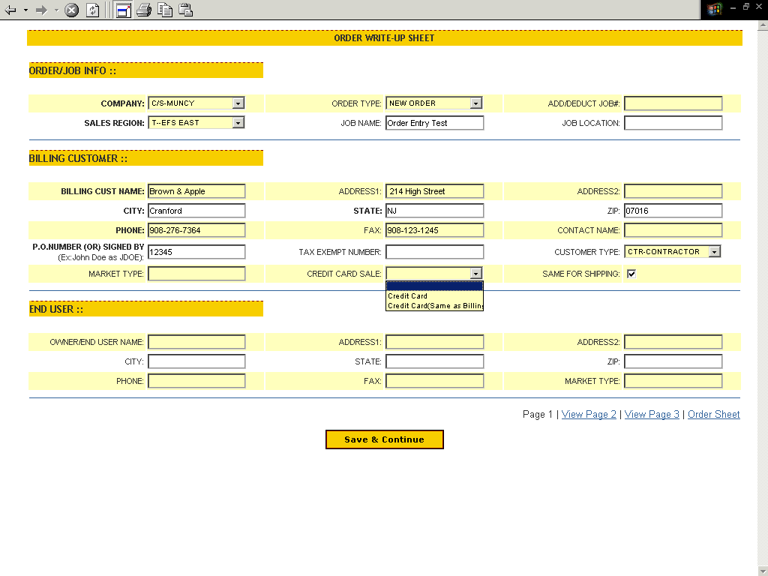
This is the first of three screens required for the write-up sheet.

Note that the Billing Customer information will be automatically populated if the “Use for Billing” box was checked in your customer information. If this box was not checked the information will need to be entered.

If a credit card is to be used, click on the selector in the “Credit Card Sale” field. Two options appear:
- Credit Card – This selection will provide an area on the third write-up screen for entering the credit card information.
- Credit Card (Same as billing) – This selection will populate the credit card information with the billing customer’s name, address etc.

Note that the ship to information on the next screen will be automatically populated with the same ship to address as the billing customer if the “Same for shipping” box is clicked off at the end of the second block (Billing Customer).

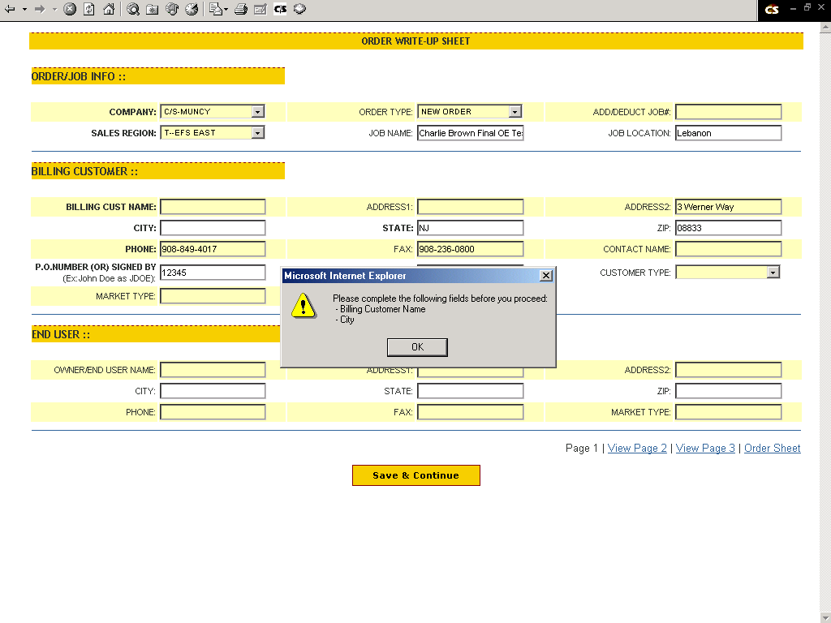

Any field that is in bold is a mandatory field. An error message as noted above will pop up if those fields are not filled in. The above error message notes that the “Billing Customer Name” and “City” must be filled in.

When complete, click on the yellow “Save & Continue” button at the bottom of the screen.

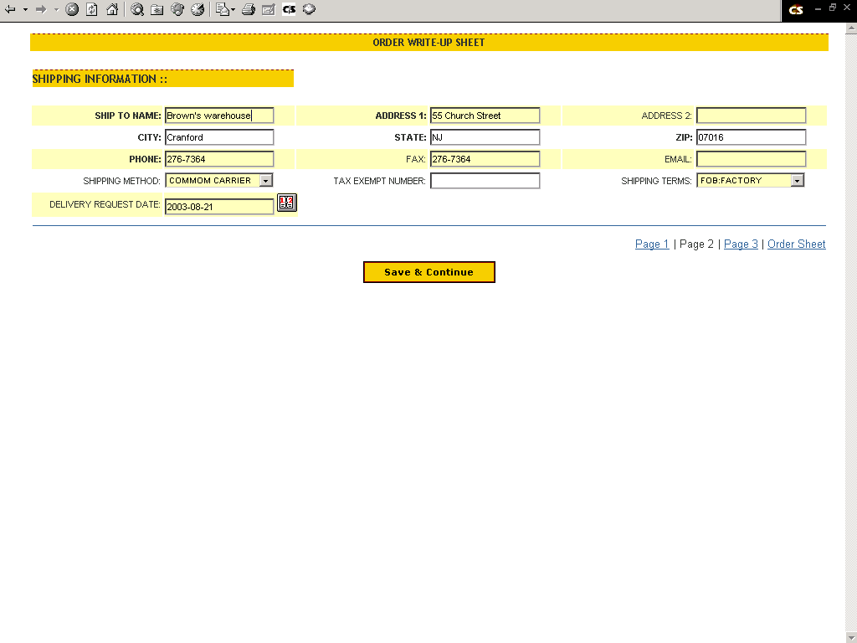

To go back to a screen at any time, click on the blue text at the bottom right of the screen. For example the “Page 1” text will take you back to page 1.

Fill out the second screen as required.

When complete, click on the yellow “Save & Continue” button at the bottom of the screen.

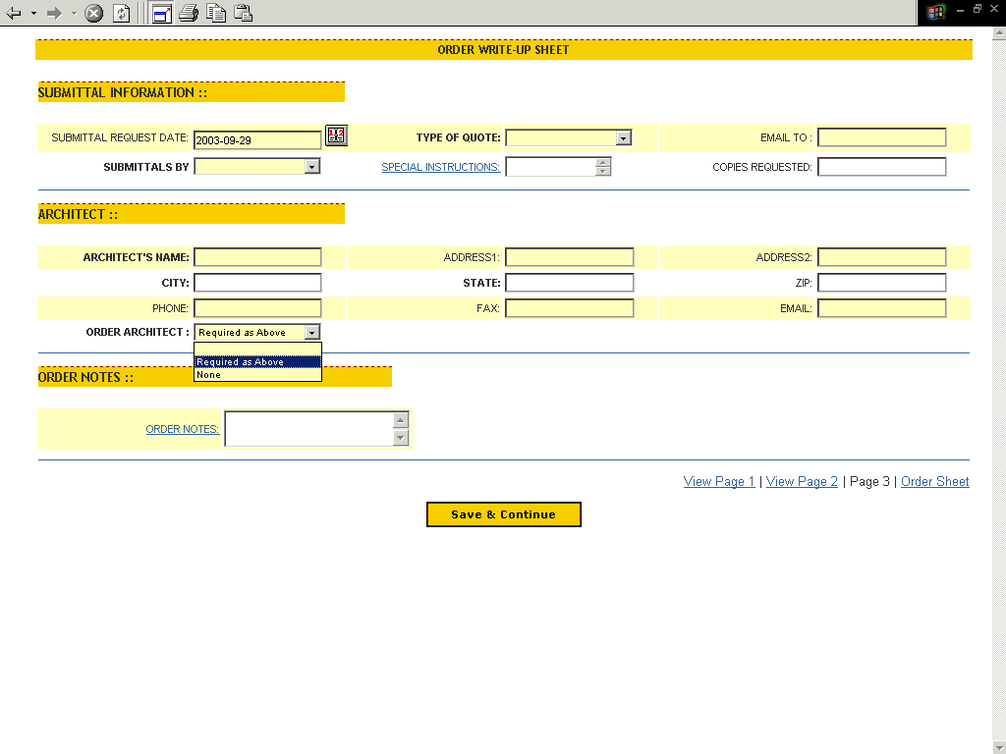

Fill out the third screen as required.

Note that the following two fields on this screen are underlined in blue lettering:
- Special Instructions (Under Submittal Information)
- Order Notes (Under Order Notes)
Both of these have text boxes that pop up by clicking on the underlined blue text.

Note that the “Order Architect” field has a drop down box. If there is not an Architect on the project, select “None” in that box.

When complete, click on the yellow “Save & Continue” button at the bottom of the screen.

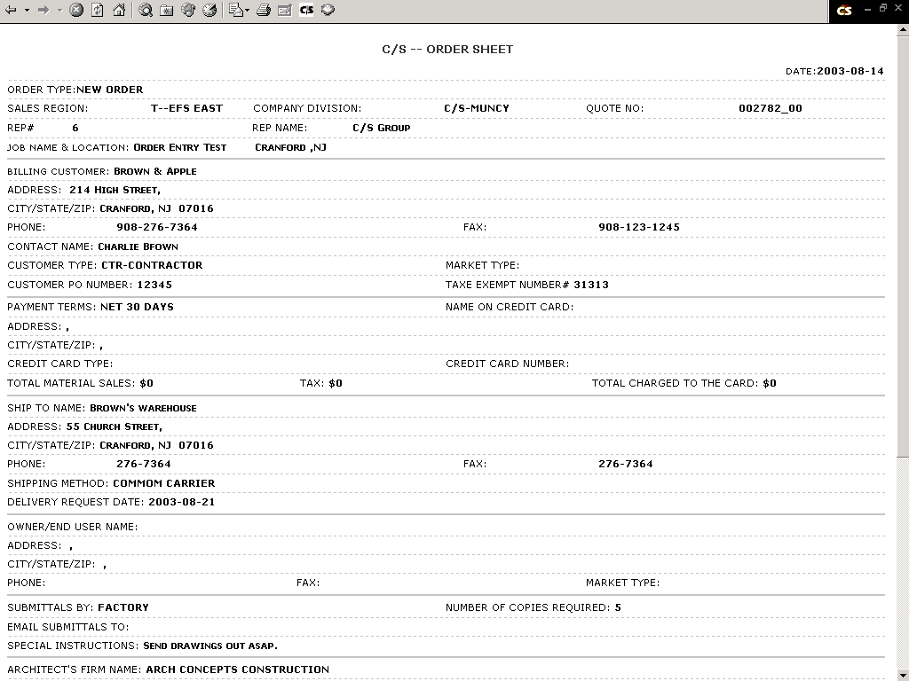

Review the write-up sheet on screen for errors.

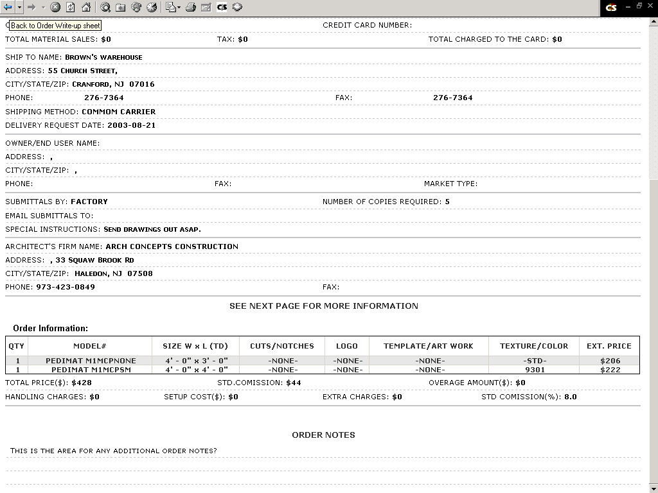

When complete, print out the order write-up sheet, or save a copy to your computer’s hard drive.

Fax or email the order write-up sheet to the EFS group along with the customer’s purchase order or signed quote.

End

